**Deploying spring boot application to ubuntu**

* In this we will try to deploy a sample spring boot application
* For application (https://referenceapplicationskhaja.s3-us-west-2.amazonaws.com/spring-petclinic-2.4.2.jar)
* Steps are
  + Install OpenJDK 11
  + Copy the file from the above-mentioned location to /usr/share/springpetclinic
  + Create a user springbootuser
  + Configure the spring boot application as Linux service
  + [Unit]
    - Description=Spring Pet Clinic
    - After=syslog.target
  + [Service]
    - User=springbootuser
    - ExecStart=/usr/bin/java -jar /usr/share/springpetclinic/spring-petclinic-2.4.2.jar
    - SuccessExitStatus=143
  + [Install]
    - WantedBy=multi-user.target

List of Linux commands

sudo apt update

sudo apt install openjdk-11-jdk -y

sudo mkdir /usr/share/springpetclinic

wget https://referenceapplicationskhaja.s3-us-west-2.amazonaws.com/spring-petclinic-2.4.2.jar

sudo cp spring-petclinic-2.4.2.jar /usr/share/springpetclinic/

sudo adduser springbootuser

sudo chown springbootuser:springbootuser /usr/share/springpetclinic/spring-petclinic-2.4.2.jar

sudo chmod 500 /usr/share/springpetclinic/spring-petclinic-2.4.2.jar

sudo vi /etc/systemd/system/springpetclinic.service

sudo systemctl enable springpetclinic.service

sudo systemctl start springpetclinic.service

Playbook code

---

- name: Deploy spring petclinic as Linux Service

hosts: appserver

become: yes

tasks:

- name: Update ubuntu packages and install java

apt:

name: openjdk-11-jdk

update_cache: yes

state: present

- name: Create a spring petclinic directory

file:

path: /usr/share/springpetclinic

state: directory

- name: download spring petclinic

get_url:

url: https://referenceapplicationskhaja.s3-us-west-2.amazonaws.com/spring-petclinic-2.4.2.jar

dest: /usr/share/springpetclinic/spring-petclinic-2.4.2.jar

- name: Create springbootuser

user:

name: springbootuser

password: springbootuser

state: present

- name: Change ownership of jar file

file:

path: /usr/share/springpetclinic/spring-petclinic-2.4.2.jar

owner: springbootuser

mode: '500'

state: file

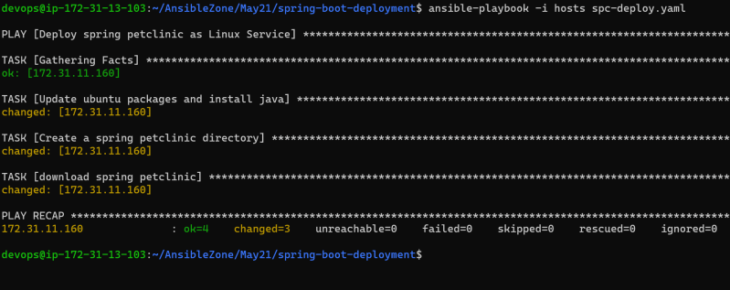

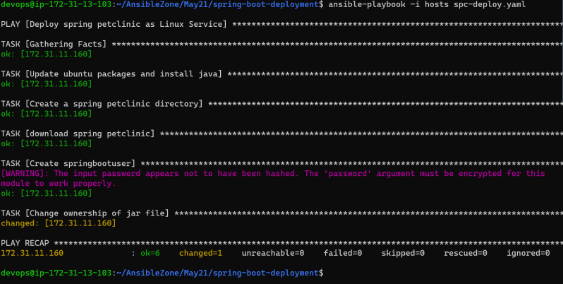

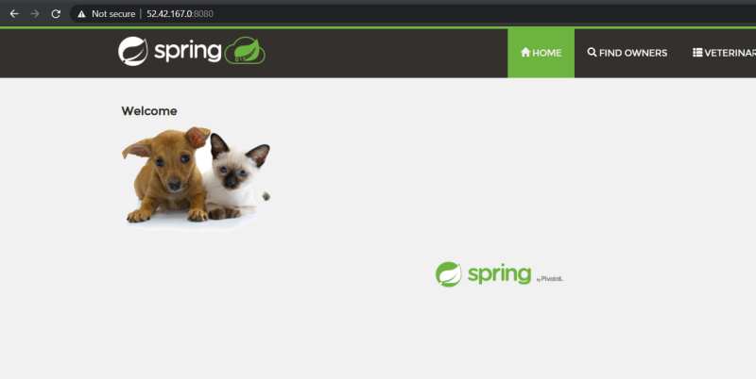

Mantra: if you can’t do things manually, you can’t automate.